Linking Verbs (Stative Verbs)

🔹 What is Linking Verbs (Stative Verbs)
# Source: AI Source: Provided by: [Data Path: Persons Table -> ID Column: 1, Name_En Column: Motasem Essam] -> From: [Chatgpt (GPT-4-turbo)] on [7/27/2025]
Linking verbs, also called stative verbs, are verbs that do not show action.
Instead, they connect the subject of a sentence with more information about the subject — often a condition or identity.

✅ Definition:
# Source: AI Source: Provided by: [Data Path: Persons Table -> ID Column: 1, Name_En Column: Motasem Essam] -> From: [Chatgpt (GPT-4-turbo)] on [7/27/2025]
A linking verb connects the subject of the sentence to a subject complement — a noun, pronoun, or adjective that describes or identifies it.
It expresses a state or condition, not an action.

🧠 Think of it as a “= sign” in a sentence.
# Source: AI Source: Provided by: [Data Path: Persons Table -> ID Column: 1, Name_En Column: Motasem Essam] -> From: [Chatgpt (GPT-4-turbo)] on [7/27/2025]
📌 Example:
- She is happy. → "She = happy"
- He became a teacher. → "He = a teacher"

🧩 Common Linking Verbs:
# Source: AI Source: Provided by: [Data Path: Persons Table -> ID Column: 1, Name_En Column: Motasem Essam] -> From: [Chatgpt (GPT-4-turbo)] on [7/27/2025]
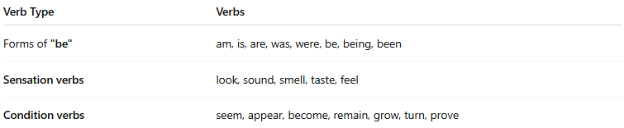

Verb Type | Verbs
Forms of "be" | am, is, are, was, were, be, being, been
Sensation verbs | look, sound, smell, taste, feel
Condition verbs | seem, appear, become, remain, grow, turn, prove

📚 Examples in Sentences:
# Source: AI Source: Provided by: [Data Path: Persons Table -> ID Column: 1, Name_En Column: Motasem Essam] -> From: [Chatgpt (GPT-4-turbo)] on [7/27/2025]
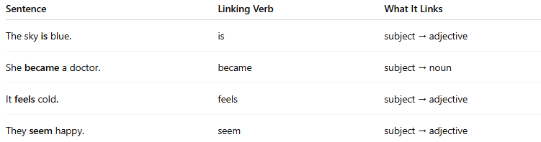
Sentence | Linking Verb | What It Links
The sky is blue. | is | subject → adjective
She became a doctor. | became | subject → noun
It feels cold. | feels | subject → adjective
They seem happy. | seem | subject → adjective

🔄 Some Verbs Can Be Both Action and Linking:
# Source: AI Source: Provided by: [Data Path: Persons Table -> ID Column: 1, Name_En Column: Motasem Essam] -> From: [Chatgpt (GPT-4-turbo)] on [7/27/2025]
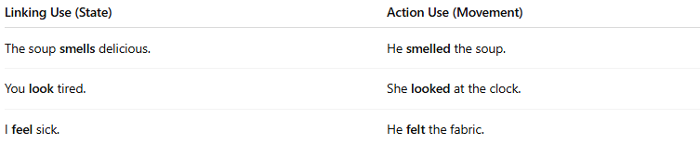
Linking Use (State) | Action Use (Movement)
The soup smells delicious. | He smelled the soup.
You look tired. | She looked at the clock.
I feel sick. | He felt the fabric.

❗ Note:
# Source: AI Source: Provided by: [Data Path: Persons Table -> ID Column: 1, Name_En Column: Motasem Essam] -> From: [Chatgpt (GPT-4-turbo)] on [7/27/2025]
- Linking verbs are often used with adjectives, not adverbs.
❌ He feels badly.
✅ He feels bad.

✅ Summary:
# Source: AI Source: Provided by: [Data Path: Persons Table -> ID Column: 1, Name_En Column: Motasem Essam] -> From: [Chatgpt (GPT-4-turbo)] on [7/27/2025]
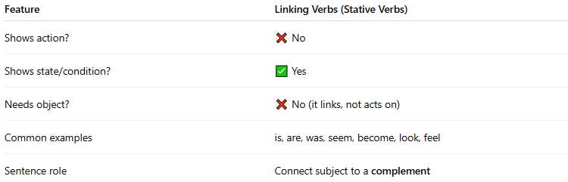

Feature | Linking Verbs (Stative Verbs)
Shows action? | ❌ No
Shows state/condition? | ✅ Yes
Needs object? | ❌ No (it links, not acts on)
Common examples | is, are, was, seem, become, look, feel
Sentence role | Connect subject to a complement

